# **Domain Name System (DNS)**

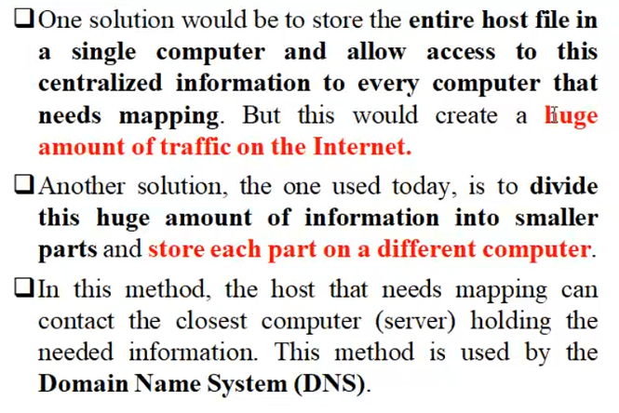

The request of the particular client is not present in the local DNS data-base (DNS-client). So the query is sent to the DNS server.

# **Need for Domain Name System (DNS)**

